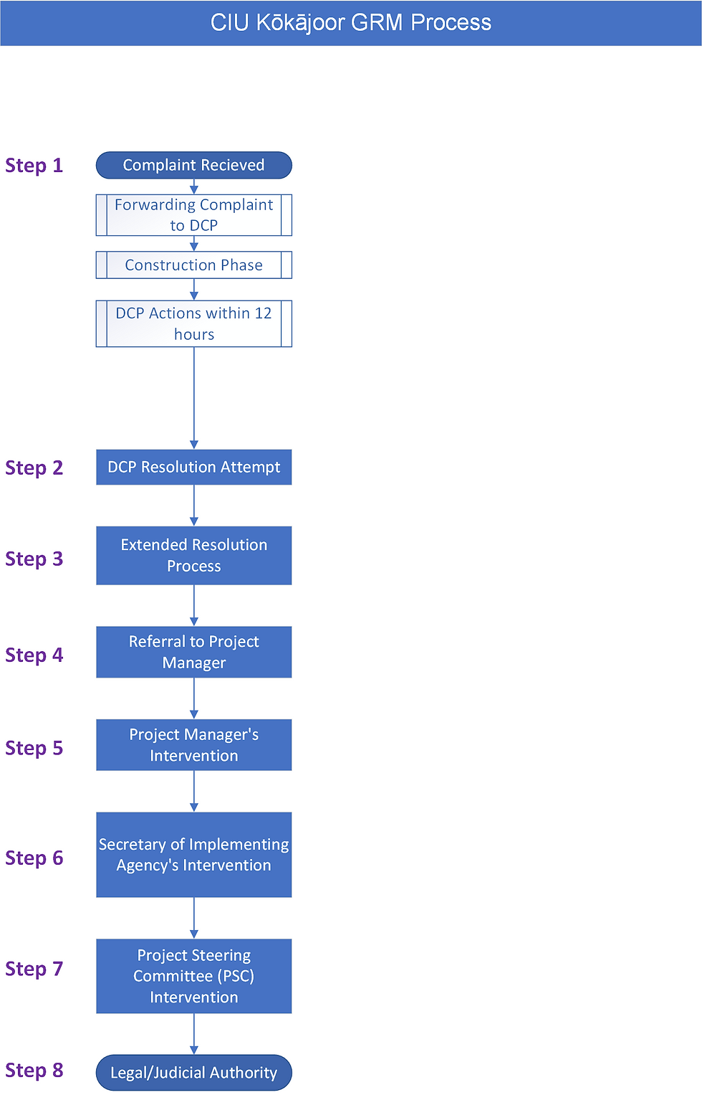

GRM Form - raise a grievance
GRM Register
Grievance Management Tools
Aggrieved Party (AP) takes concern or complaint to Designated Contact Person (DCP) or anyone else involved with Project (Recipient).
The Recipient must forward all information received to the DCP within 12 hours of receiving complaint.
During construction, the Construction Site Supervisor (CSS) is DCP subject to this process in all matters
Within 12 hours of receipt, DCP to log concern/complaint (see GRM Register, GRM Form) and determine if concern or complaint is:
- Project-related. If not, DCP to advise AP and forward concern or complaint to appropriate authority. Complaint logged on the GR Register, and case closed.
- Sensitive or serious? For GBV, SEA/H or VAC or Human Trafficking, DCP to immediately refer survivor to WUTMI, and escalate to the Project Manager and notify CIU Safeguards Team and the World Bank (WB) Project Team Leader.
DCP notifies the Project Manager and endeavors to resolve the concern or complaint within 12 hours of logging the grievance. For complaints that are satisfactorily resolved the nature and time of resolution is logged.
If issue is unable to be resolved by the DCP (within 12 hours of lodging), DCP will continue to process the grievance (with input from other parties as appropriate) with the AP with AP’s approval. Time limit within 2 weeks of logging grievance. For some projects, primarily those Projects coming under the WB ESF (does not include PREP II or SEDEP for example) this may be extended by mutual agreement).
Where the AP is not satisfied with the resolution from Step 3, the DCP will refer the AP to the Project Manager. Completed within 2 weeks after logging grievance (or longer as mutually agreed)
The Project Manager endeavors to address and resolve the complaint and informs the AP in writing. To be completed within 2 weeks after GM receives complaint. For complaints that were satisfactorily resolved by the Project Manager the incident and resultant resolution will be logged by the DCP.
The Secretary of the Implementing Agency endeavors to address and resolve the complaint and inform the AP. If the matter remains unresolved within 2 weeks of the Secretary receiving the complaint, or AP is not satisfied with the outcome, the Secretary will then refer to matter to the Project Steering Committee (PSC) for a resolution. The DCP will log details of issue and resultant resolution status.
Project Steering Committee tries to resolve the issue within 1 month after PSC receives complaint.
If complaint remains unresolved or the AP is dissatisfied with the outcome proposed by the PSC, he/she is free to refer the matter to the appropriate legal or judicial authority. A decision of the Court will be final

