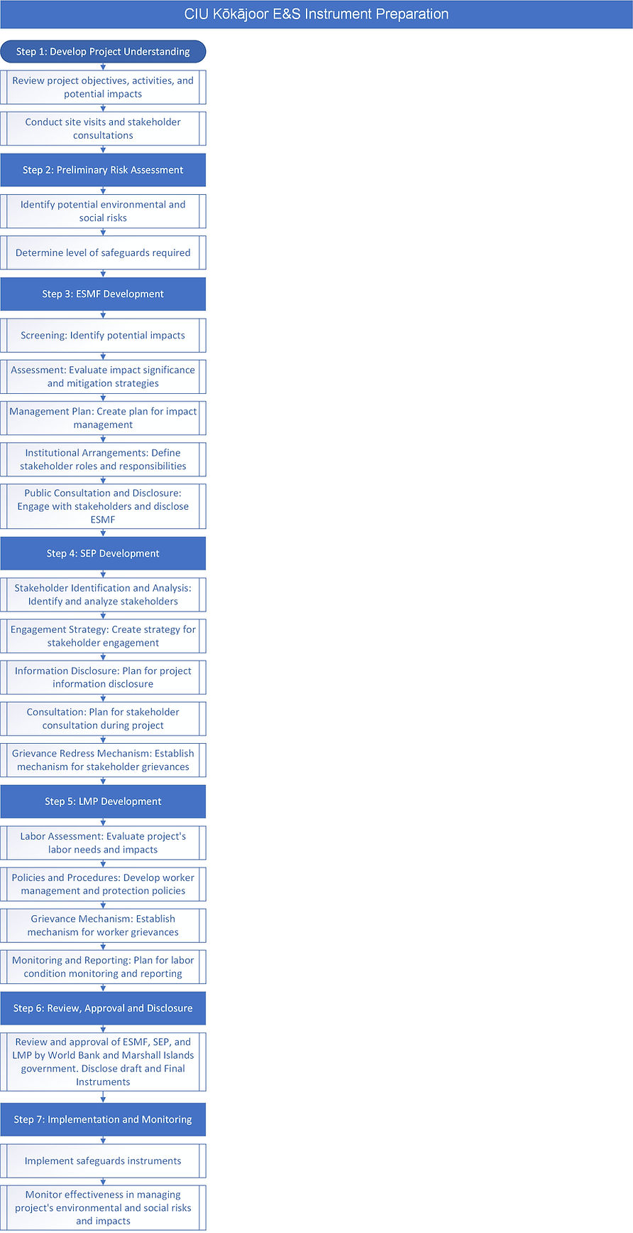
- After approval, the safeguards instruments should be implemented and regularly monitored to ensure they are effective in managing the project's environmental and social risks and impacts.

- ESMF, SEP, and LMP to be reviewed and approved by the WB and the government of the Marshall IslandsGoRMI. DRAFT instruments to WB Task Team SG and IA for preliminary feedback. Disclose DRAFT on CIU SG website. – incorporate feedback and compile final draft instruments. Disclose FINAL on CIU SG website (delete DRAFTs).

- Assess the project's labor needs and potential impacts on workers.
- Develop policies and procedures for managing and protecting workers, including measures for occupational health and safety.
- Establish a mechanism for workers to raise concerns or complaints.
- Outline how labor conditions will be monitored and reported.

- Identify and analyze the project's stakeholders, including affected communities, government agencies, and civil society organizations.
- Develop a strategy for engaging with these stakeholders throughout the project lifecycle.
- Outline how information about the project will be disclosed to stakeholders.
- Plan how stakeholders will be consulted during project design and implementation.
- Establish a mechanism for stakeholders to raise concerns or complaints about the project.

- Identify the potential environmental and social impacts of the project. This should include both positive and negative impacts.
- Assess the significance of these impacts and identify ways to avoid, minimize, or mitigate them.
- Develop a plan for managing these impacts, including measures for monitoring and reporting.
- Outline the roles and responsibilities of different stakeholders in implementing the ESMF.
- Consult with affected communities and other stakeholders on the draft ESMF and disclose the final document publicly.

- Identify potential E&S risks and impacts to determine safeguards instruments required. See ESRS. Discuss risk factors with WB Task Team Safeguards personnel and get written confirmation (email). Site visits - photos; if possible, obtain drone footage where works are intended.

- Understand the Project - attend Preparation Mission Meetings, review documents (including Environmental and Social Risk Assessment (ESRS) prepared by WB Task Team), conduct site visits (essential if writer has not visited the location), and consult with project stakeholders.

Step 1: Develop Project Understanding
- Understand the Project - attend Preparation Mission Meetings, review documents (including Environmental and Social Risk Assessment (ESRS) prepared by WB Task Team), conduct site visits (essential if writer has not visited the location), and consult with project stakeholders.
Step 2: Preliminary Risk Assessment
- Identify potential E&S risks and impacts to determine safeguards instruments required. See ESRS. Discuss risk factors with WB Task Team Safeguards personnel and get written confirmation (email). Site visits - photos; if possible, obtain drone footage where works are intended.
Step 3: ESMF Development
- Identify the potential environmental and social impacts of the project. This should include both positive and negative impacts.
- Assess the significance of these impacts and identify ways to avoid, minimize, or mitigate them.
- Develop a plan for managing these impacts, including measures for monitoring and reporting.
- Outline the roles and responsibilities of different stakeholders in implementing the ESMF.
- Consult with affected communities and other stakeholders on the draft ESMF and disclose the final document publicly.
Step 4: SEP Development
- Identify and analyze the project's stakeholders, including affected communities, government agencies, and civil society organizations.
- Develop a strategy for engaging with these stakeholders throughout the project lifecycle.
- Outline how information about the project will be disclosed to stakeholders.
- Plan how stakeholders will be consulted during project design and implementation.
- Establish a mechanism for stakeholders to raise concerns or complaints about the project.
Step 5: LMP Development
- Assess the project's labor needs and potential impacts on workers.
- Develop policies and procedures for managing and protecting workers, including measures for occupational health and safety.
- Establish a mechanism for workers to raise concerns or complaints.
- Outline how labor conditions will be monitored and reported.
Step 6: Review, Approval and Disclosure
- ESMF, SEP, and LMP to be reviewed and approved by the WB and the government of the Marshall IslandsGoRMI. DRAFT instruments to WB Task Team SG and IA for preliminary feedback. Disclose DRAFT on CIU SG website. – incorporate feedback and compile final draft instruments. Disclose FINAL on CIU SG website (delete DRAFTs).
Step 7: Implementation and Monitoring
- After approval, the safeguards instruments should be implemented and regularly monitored to ensure they are effective in managing the project's environmental and social risks and impacts.

